***Language Skills***

1. ***Fill in the gaps with words given in the box. Change the form if necessary.***

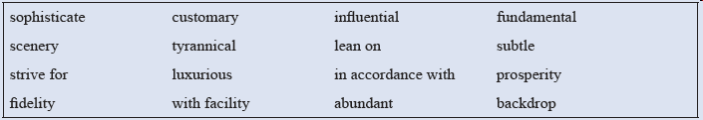

(1) Honey bees use one of the most ____________ communication systems of any insect.

(2) He was one of the most ____________ performers of modern jazz.

(3) Our constitution embodies all the ____________ principles of democracy.

(4) Due to his ____________ reign on his empire, the country fell deeply into lawlessness, poverty and despair.

(5) She ____________ him to help her to solve her economic problems.

(6) We always ____________ excellence in quality and perfect after-sales service for the purpose.

(7) ___________________ her wishes, she was buried in France with her husband.

(8) The country was on the verge of becoming ____________ and successful.

(9) The husband and the wife should be loyal to each other. We should not only talk about the wife’s ____________ to her husband.

(10) The area has a(n) ____________ of wildlife, including lions, tigers, crocodiles and so on.

***2. Translate the following sentences with the words given in the Brackets.***

1. 中国菜肴遍布世界各地，已然成为令人印象深刻并且影响深远的文化象征。（corner；impressive；influential；symbol）
2. 许多外国人都对筷子非常感兴趣，但是对如何熟练地使用筷子却感到困惑。（puzzle；with facility）
3. 吃时令菜已被看成中国饮食文化中的重要特征之一。（season；regard as；feature）
4. 中国菜肴贵在色、形、香、味俱全，这也是中国饮食文化的重要特征之一。（cuisine；excellence；aroma；taste）